**Lab Task#3**

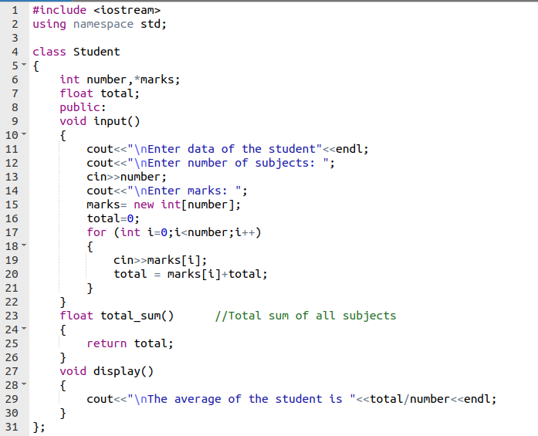

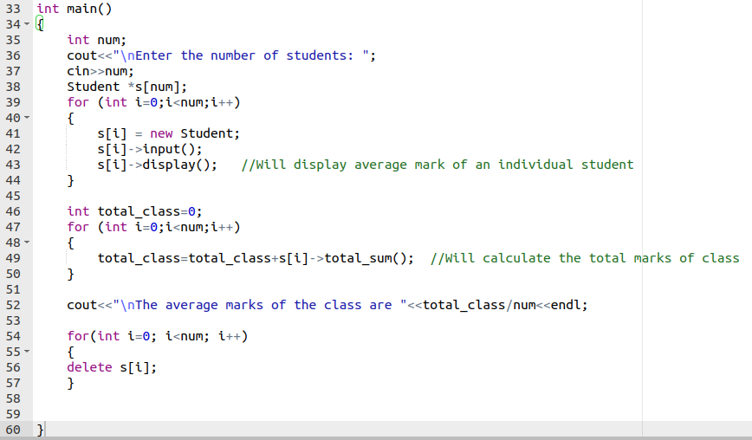

**OUTPUT**

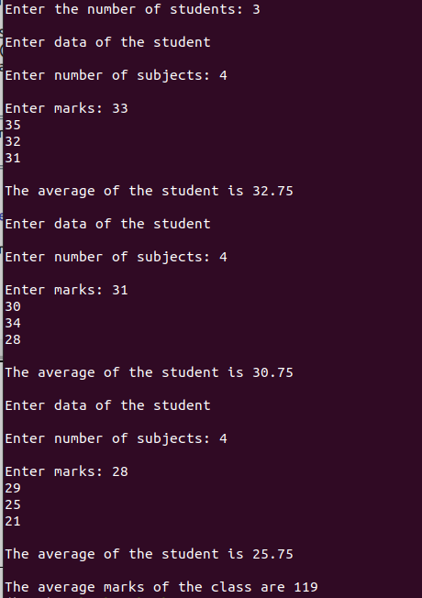

**Lab Task#4**

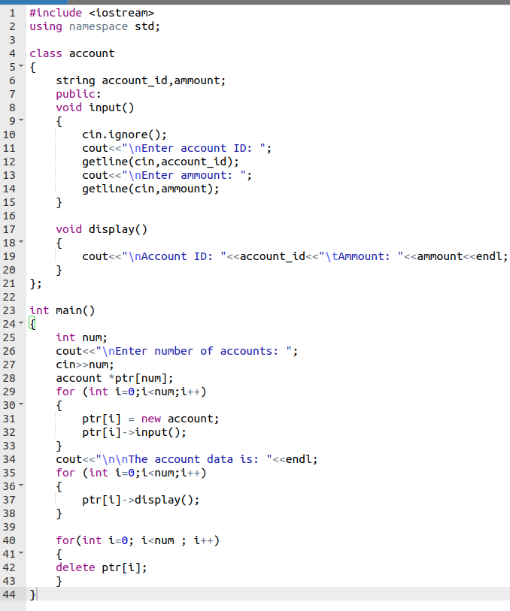

**OUTPUT**

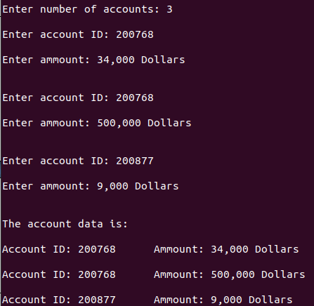

**Conclusion:**

In this lab I learned I learned how to create dynamic variables using pointers in classes. I also learned how to create dynamic objects of classes using the ‘new’ operator and then delete the pointers of classes afterwards. Moreover, pointers help us to save space on stack.